# MQTT

MQTT is a critical part in this project due to its role. To push and pull data from the device to the database, MQTT, as a bridge that can open the connection to allow data transfer from device to database and in opposite way

To setup MQTT broker, there are some key phases:

1. Install Node.js (run PowerShell as administrator):

with the following command:

npm install -g --unsafe-perm node-red

To check the installation, use command:

node-red

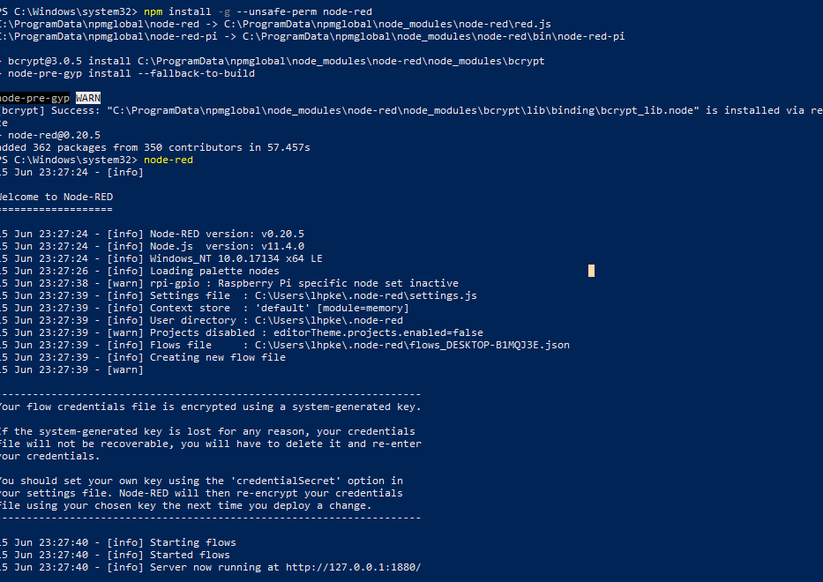

As it can be seen that the server is running at <http://127.0.0.1:1880/> which the IP address is 127.0.0.1 and port 1880

Then install the node-red dashboard with command npm install node-red-dashboard

Copy and paste the following link to web browser to access the node-RED

Next, install the mosquito. After installing, go to the source folder of mosquito and run it by command prompt

